**Aim** : Commands in impala

**impala-shell**

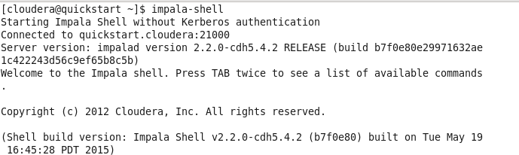

**select version();**

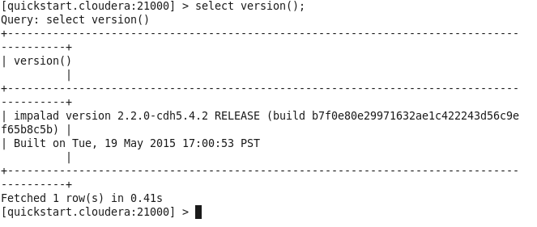

**Show databases:**This command will list existing databases in impala.

**show databases;**

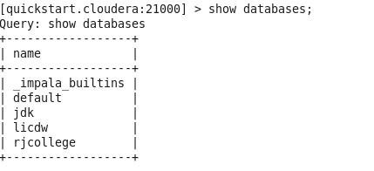

**select current_database();**

**show tables**;

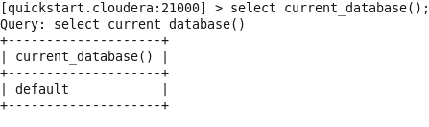

**show tables in jdk;**

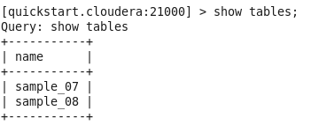

**show tables like 'sample*';**

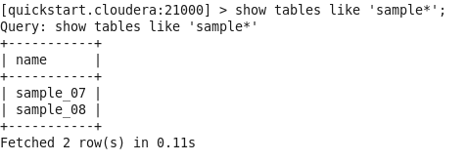

**Create a database:**This command is used to create a database.

**Syntax:** create database <database_name>

**create database RJ;**

**show databases;**

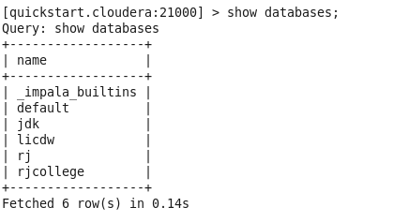

**use RJ;**



**Create table:**This command is used to create tables.

**Syntax:** create table <table_name>(field_name1 data_type, field_name2 data_type);  
**create table t1 (x int);**

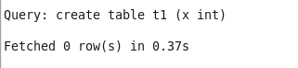

**Show tables is used to view all the tables in current database**

**show tables;**

**select current_database();**

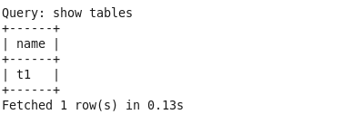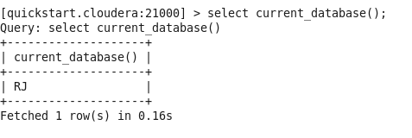

**Insert:**This command is used to insert records in either overwrite or append record in tables.

**Syntax:** Insert into <database_name>.<table_name> values(field_value1, field_value2)  
**insert into t1 values (1),(3),(2),(4);**

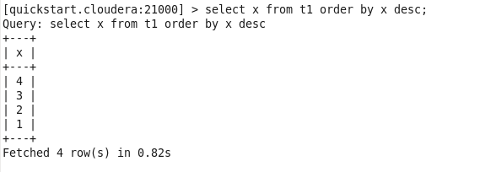

**Order by : This is used to sort the data**

**select x from t1 order by x desc;**

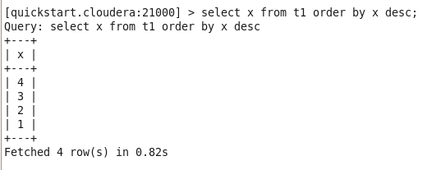

**Aggregate functions:**

**select min(x), max(x), sum(x), avg(x) from t1;**

